**MAKERERE** **UNIVERSITY**

**COLLEGE OF COMPUTING AND INFORMATION SCIENCES**

**SCHOOL OF COMPUTING AND INFORMATICS TECHNOLOGY**

**DEPARTMENT OF NETWORKS**

**RESEARCH PAPER FOR SMART HOME SYSTEM**

**16th December 2019**

**Prepared by BSE20-43**

**Abstract**

A smart home environment can be defined as dwelling incorporating communication network which connects the key electrical appliances and services and allows them to be remotely controlled, monitored or accessed.

In Uganda today, most people control their appliances manually and they need a way to automate the activities in their homes to make their life easy and comfortable. The purpose of this research is to find out what people features they need to be automated in their homes.

We used a quantitative method to carry out this research and the data collection tool we used was questionnaire.

# INTRODUCTION

## Background to the study

A smart home refers to a home equipped with a communication network, high-tech household devices, appliances and sensors that can be remotely accessed, monitored and controlled and can provide services responding to the user’s needs.

This research was conducted to obtain information from people that will help us to design and develop the Smart Home system to automate the activities in homes and solve the problem of performing manual activities in the house.

## Statement of the problem

The problem this project will address is the managing and controlling of the home activities manually.

## Research questions

This research aimed at finding out views of people about smart home and which features they would like to be automated in their homes. And the aim was to answer the following questions:

1. If they have heard about smart homes?
2. What have they heard about it?
3. Do they trust technological products?
4. Would they like to automate their homes?
5. Why would they like to automate their homes?
6. What functions are important for them in a smart home?
7. How would they like to install this system?
8. Why they are not interested to automate their homes?
9. What are their worries for smart homes?
10. When will smart homes become part of our everyday life?

## Objective of the study

The main objective of this study is to design and develop a smart home system that can automate the control of different home appliances in a home.

## Scope of the study

This study focuses on obtaining information about people’s views on automation of different home appliances which include lights, doors, TV, fans and alarms.

# LITERATURE REVIEW

The following solutions have tried to address the issue of Home automation.

## Bluetooth based home automation system using cell phones:

In Bluetooth based home automation system the home appliances are connected to the Arduino BT board at input output ports using relay. The program of Arduino BT board is coded in C language of microcontrollers; the connection is made via Bluetooth. The password protection is provided so only authorized user is allowed to access the appliances. The Bluetooth connection is established between Arduino BT board and phone for wireless communication. In this system the python script is used and it can install on any of the Symbian OS environment, it is portable. One circuit is designed and implemented for receiving the feedback from the phone, which indicate the status of the device.[1]

## ZigBee based home automation system using cell phones:

To monitor and control the home appliances the system is designed and implemented using Zigbee. The device performance is record and store by network coordinators.

For this the Wi-Fi network is used, which uses the four switch port standard wireless ADSL modern router. The network SSID and security Wi-Fi parameter are preconfigured. The message for security purpose first process by the virtual home algorithm and when it is declared safe it is re-encrypted and forward to the real network device of the home. Over Zigbee network, Zigbee controller sent messages to the end. The safety and security of all messages that are received by the virtual home algorithm. To reduce the expense of the system and the intrusiveness of respective installation of the system Zigbee communication is helpful. [1]

## GSM based home automation system using cell phones:

Because of the mobile phone and GSM technology, the GSM based home automation is lure to research. The SMS based home automation, GPRS based home automation and dual tone multi frequency (DTMF) based home automation, these options we considered mainly for communication in GSM. The system use transducer which convert machine function into electrical signals which goes into microcontroller. The sensors of system convert the physical qualities like sound, temperature and humidity into some other quantity like voltage. The microcontroller analysis all signal and convert them into command to understand by GSM module. Select appropriate communication method among SMS, GPRS and DTFC based on the command which received GSM module.[1]

## Wi-Fi based home automation system using cell phones:

Wi-Fi based home automation system mainly consist three modules, the server, the hardware interface module, and the software package. Wi-Fi technology is used by server, and hardware Interface module to communicate with each other. The same technology uses to login to the server web based application. The server is connected to the internet, so remote users can access server web based application through the internet using compatible web browser. Software of the latest home automation system is split to server application software, and Microcontroller (Arduino) firmware. The Arduino software, built using C language, using IDE comes with the microcontroller itself. Arduino software is culpable for gathering events from connected sensors, then applies action to actuators and preprogramed in the server. Another job is to report the and record the history in the server DB. The server application software package for the proposed home automation system, is a web based application built using asp.net. The server application software can be accessed from internal network or from internet if the server has real IP on the internet using any internet navigator supports asp.net technology. Server application software is culpable of, maintain the whole home automation system, setup, configuration. Server use database to keep log of home automation system components. [1]

# RESEARCH METHODS

The table below describes the research methods used in achieving the research objectives and how research methods were used during this research.

|  |  |  |
| --- | --- | --- |
| Research objective | Research method used | How research method was used |
| To find out if people have heard about smart homes | 1. Questionnaires | Questionnaires were given to people in homes who later filled them. |
| To find out if people would like to automate their homes | 1. Questionnaires | Questionnaires were given to people in homes who later filled them. |
| To know why they would like to automate their homes | 1. Questionnaires 2. Observation | 1. Questionnaires were given to people in homes who later filled them. 2. The Smart home system team were able to observe how people manually manage their home activities. |
| To find out the functions they would like to be automated in their homes | 1. Questionnaires | Questionnaires were given to people in homes who later filled them. |
| To find out why they are not interested in automating their homes | 1. Questionnaires | Questionnaires were given to people in homes who later filled them. |
| To know what are the worries about smart homes | 1. Questionnaires | Questionnaires were given to people in homes who later filled them. |

# RESULTS OF THE STUDY

In our survey for the smart home questionnaire, we got a total of 150 responses.

## What is your Gender?

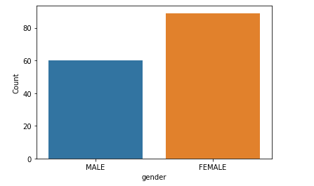

For this question we had 149 responses out of which we had both male and female respondents. But we had more females than the males.

## What is your Age?

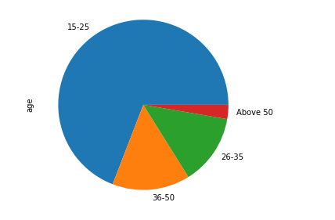

Out of the 149 responses, most of the respondents were of age limit 15-25, which is the youth. Then we also had a few numbers of age 26-50. We also had a respondent of age above 50.

From this analysis we can say we had responses from all generations. But the most were youths of age 15-25.

## Have you heard about smart homes before?

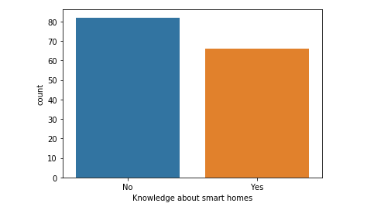

We had 148 responses for this question. 55% of the people who responded to this question didn’t know about smart homes and the rest of them knew about it. But we had more people who had no idea about what smart homes are.

## If yes, what have you heard about them? What do you know about smart homes?

* No
* nothing
* Seen many videos on internet about automation and technology with which homes are managed effectively
* It's like intelligent building. Technology enhanced secured, observed by camera, eco-friendly building
* Smart homes contains smart devices. Basic home functionality complete easily with help of technology
* I don't know enough about it I think it is the automation of homes
* Smart which makes your life so romantic!! Yes I deserve it. easy and smart life
* Smart homes are basically operated with electronic devices that I heard like light, lock systems etc.
* Smart homes make home easier with schedules and much more. Now in market with have google home and amazon Alexa which with many other devices who can control houses by voice commands and have schedules which save power and etc.
* amazon, Alexa, google assistant, Philips have bio-metric locks, smart tv, home air purifier
* all the activities of home are done by machines
* Gadgets, equipment’s and machines those are operated through a remote sitting at one point. E.g.: light adjustments in your room, operating fire place through remote, room temperature control
* smart homes with all electrical appliances and use things in easy way
* it is easy to operate from anywhere
* security system, camera, fingerprint, can control fridge, tv, water heater, AC from mobile device
* perfect sensor alarms, auto electric switch, compact multi user furniture, more greenery
* homes where space is optimally utilized and comprises of all modern electronic gadgets where domestic and entertainment activities are available at easy disposal
* Every thing is connected to google via internet ...u can direct operations like locking ..unlocking making coffee...turning tv ..playing music...turning on lights...automatically..
* Smart homes is when homes are electronically connected and can be controlled by remote and you can choose who uses the sys.
* Automated. Electronic and Tech evolved in terms of security, lighting etc.
* They have a good security system.
* Automated home systems
* Everything related to home in smart way
* Smart homes are intelligent homes which assists us in routine prescribed activities which results into efficiency as well as cost saving
* Everything works with technology
* Highly technology based homes
* Home automation
* A smart home has new technologies that make your work easy and simple to save time and space.
* Wifi controlled homes, new technology innovation
* A smart home is a home with technology that helps us communicate between smart devices and more control of your home automatically
* A lot, prefer google home, they useful only if you live in a modern house where most of your devices are capable of connecting to them.
* Everything in the home is automatic. Like lights and fan can get started with just a touch on the phone
* Smart phones n smart tv
* Automated
* Eco friendly
* They use the latest technology systems
* In the smart home it use of internet of thing (IoT).in this the automatic door open,advans security and etc. process is working with help of Arduino.
* A smart home is a residence that uses internet-connected devices to enable the remote monitoring and management of appliances and systems, such as lighting, heating, cooling, garage door, CCTV cameras most of electronics devices entertainment devices such as.. tv, Alexa, Eco, home theatre
* Nothing
* they are gesture controlled
* Amazing
* Smart homes are homes with modern technology which helps an individual to carry out day to day chores invert efficient manner.
* Alexa house
* Makes automation possible in homes
* Smart home technology tends to be user friendly as it is controlled by internet connected devices. Makes life easier for people staying at home. However, it makes people lazy and heavily dependent on technology which is not good. Also, it’s quite expensive to create.
* They are controlled through the internet. E.g. a tablet
* A home that works digital using artificial intelligence
* More like automated homes...artificial intelligence
* Automatically turn off and on lights battery savery
* A phone with versatile features and functioning.
* I haven’t heard of them, but I guess its technological advancements in homes and our daily living.
* U can operate any electronic gadgets through smartphone
* Smart home with all the latest technologies
* Home automation or domotics is building automation for a home, called a smart home. Smart home has automation system that have control over lighting, climate, entertainment systems, home security.
* Connecting lights to a system and other appliances + security controls too
* Through the internet, especially the 5G network. These homes are automated.
* Where everything like lights tv and all can be controlled through remote or phone or sensor
* Remote controlled homes or sensor controlled homes
* Its controlled by electronic gadgets
* Computer controlled with internet that improves air conditioning, entertainment
* Smart homes are modern technology approach towards convenient safe n secured life style.
* Not much really, but they're awesome in the sense of controlling all utility in the house. And the security of the house

We had 67 responses for this question as it was only for the people who had an idea of what smart homes are. And from the above replies we can say that mostly all of them knew how a smart home works and what it can do and how it can make our life easy with the help of technology and internet.

## Do you trust this kind of products?

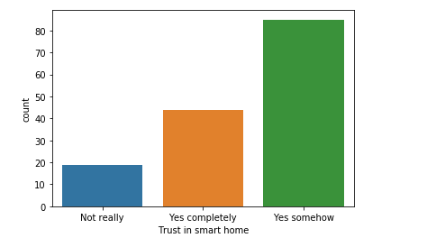

We had 148 responses for this question. We had people who trust and who don’t trust technological products. But we have more people who trust technological products than the people who don’t trust these kind of products. There are very few people who don’t trust these kind of products.

## Are you generally interested in technological products?

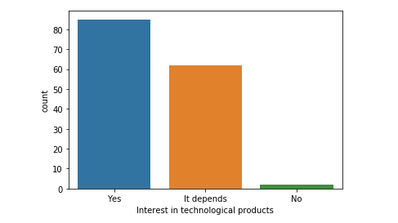

We had 149 responses for this question. from the above we can say that most people are interested in technological products and some of them are interested only on knowing what the product is about.

## Would you be interested in automating your home?

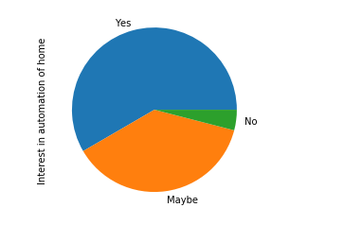

We had 149 responses for this questions. A high number of respondents are interested in automating their homes. Only few are not interested in automating their homes.

## Why would you like to automate your home?

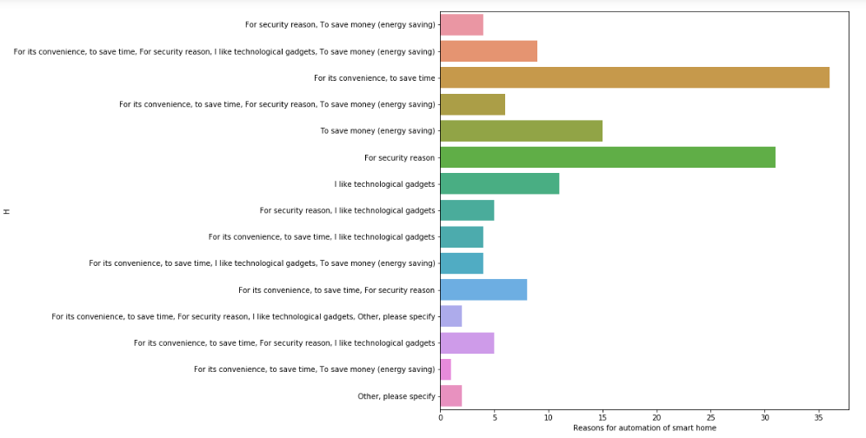

We had 143 responses for this question. We had respondents who agrees that it’s convenient, it saves time, it’s secured, they like technological gadgets, to save money and some had other reasons. But we had the highest number of respondents who want to automate their homes as it is convenient and it saves their time. We also had a few respondents who wants to automate their homes for security reasons. But we also had people who wanted to automate their homes in order to save money and as they like the technological gadgets.

## Which of these functions would be the most important for you? Please rank the options from most important (1) to least important(5).

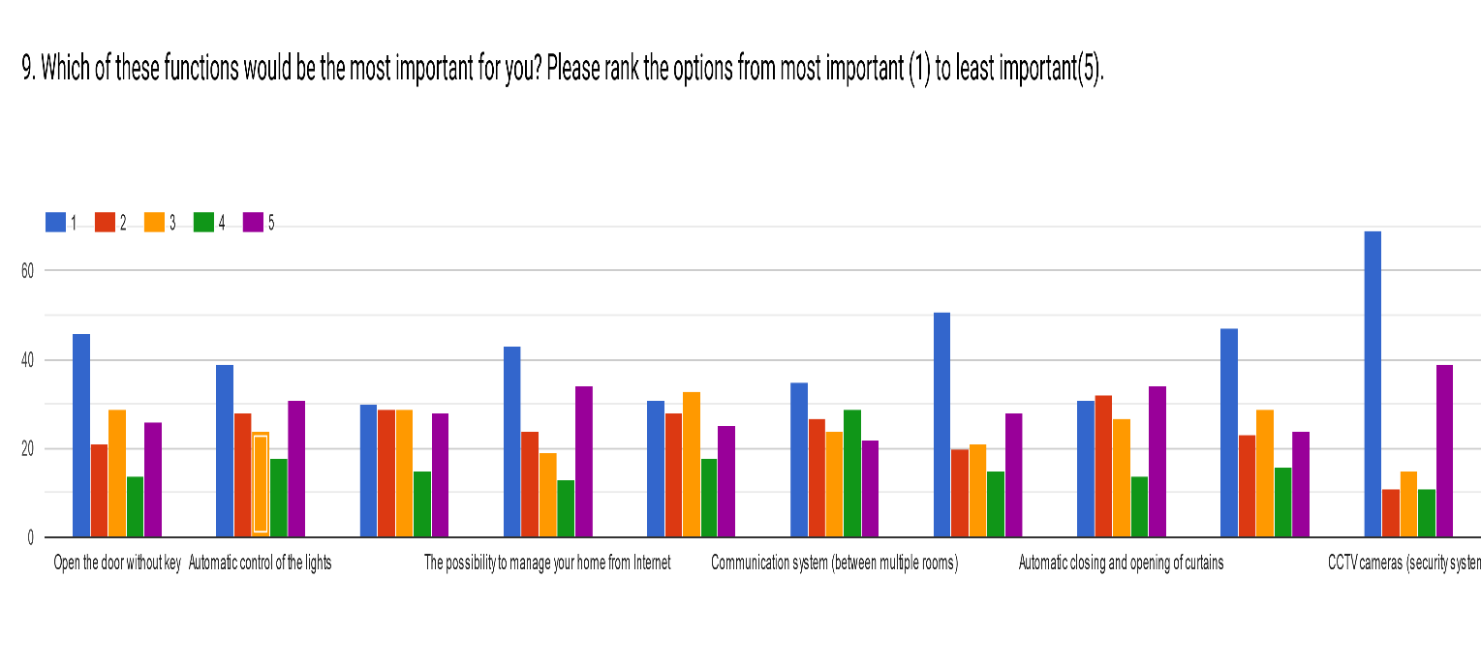

We got responses for all the options for this question.

* Open the door without key – this was very important for highest number of respondents and least important for few.
* Automatic control of lights – it was more important for most of the respondents then the rest.
* Automatic shutters and blinds – it was important for half of the respondents and least important for the rest.
* The possibility to manage your home from internet – it was important for high number of respondents and least important for some of them.
* Manage the heating – it was not that important for most of the respondents but it was somehow important for some.
* Communication system (between multiple rooms) – it was important for a high number of respondents and least important for few.
* Automatic management of the home alarm system – it was the most important for a highest number of respondents and least important for few respondent.
* Automatic closing and opening of curtains – it was the least important for a high number of respondents and more important only for few respondents.
* Managing home appliances automatically (TV, refrigerator, AC, washing machine, microwave, oven) – it was very important for highest number of people and least important for few respondents.
* CCTV cameras (security system) – it was very important for the highest number of respondents and least important for some of them.

## If you were to install this kind of products at home, how would you prefer to do?

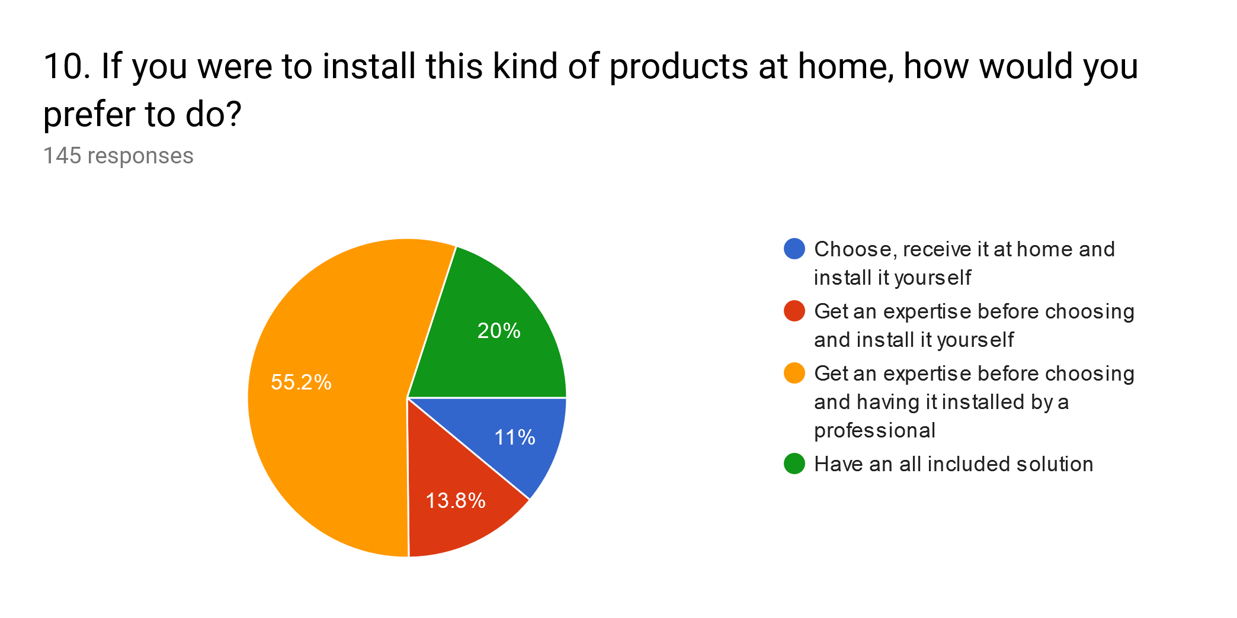

We had 145 responses for this question. More than half of the respondents wanted an expertise before choosing and having it installed by a professional. Some wanted to get an expertise before choosing and installing. Few wanted to choose and receive it at home and install it by themselves. Few wanted an all included solution.

But the highest number of respondents wanted an expertise before choosing and having it installed by a professional.

## Would you allow your smart home to record your house health status? (In case of power failure, smoke, fire) Mark only one oval.

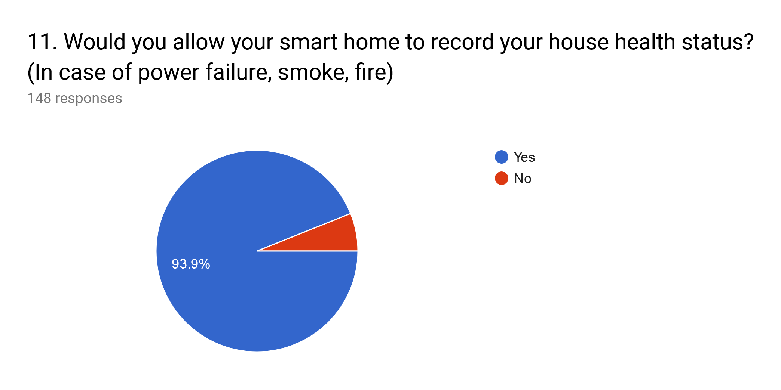

We had 148 responses for this question. Highest number of respondents want their smart home to record their house health status. Only few didn’t want to record their house health status.

## Why aren't you interested in automating your home?

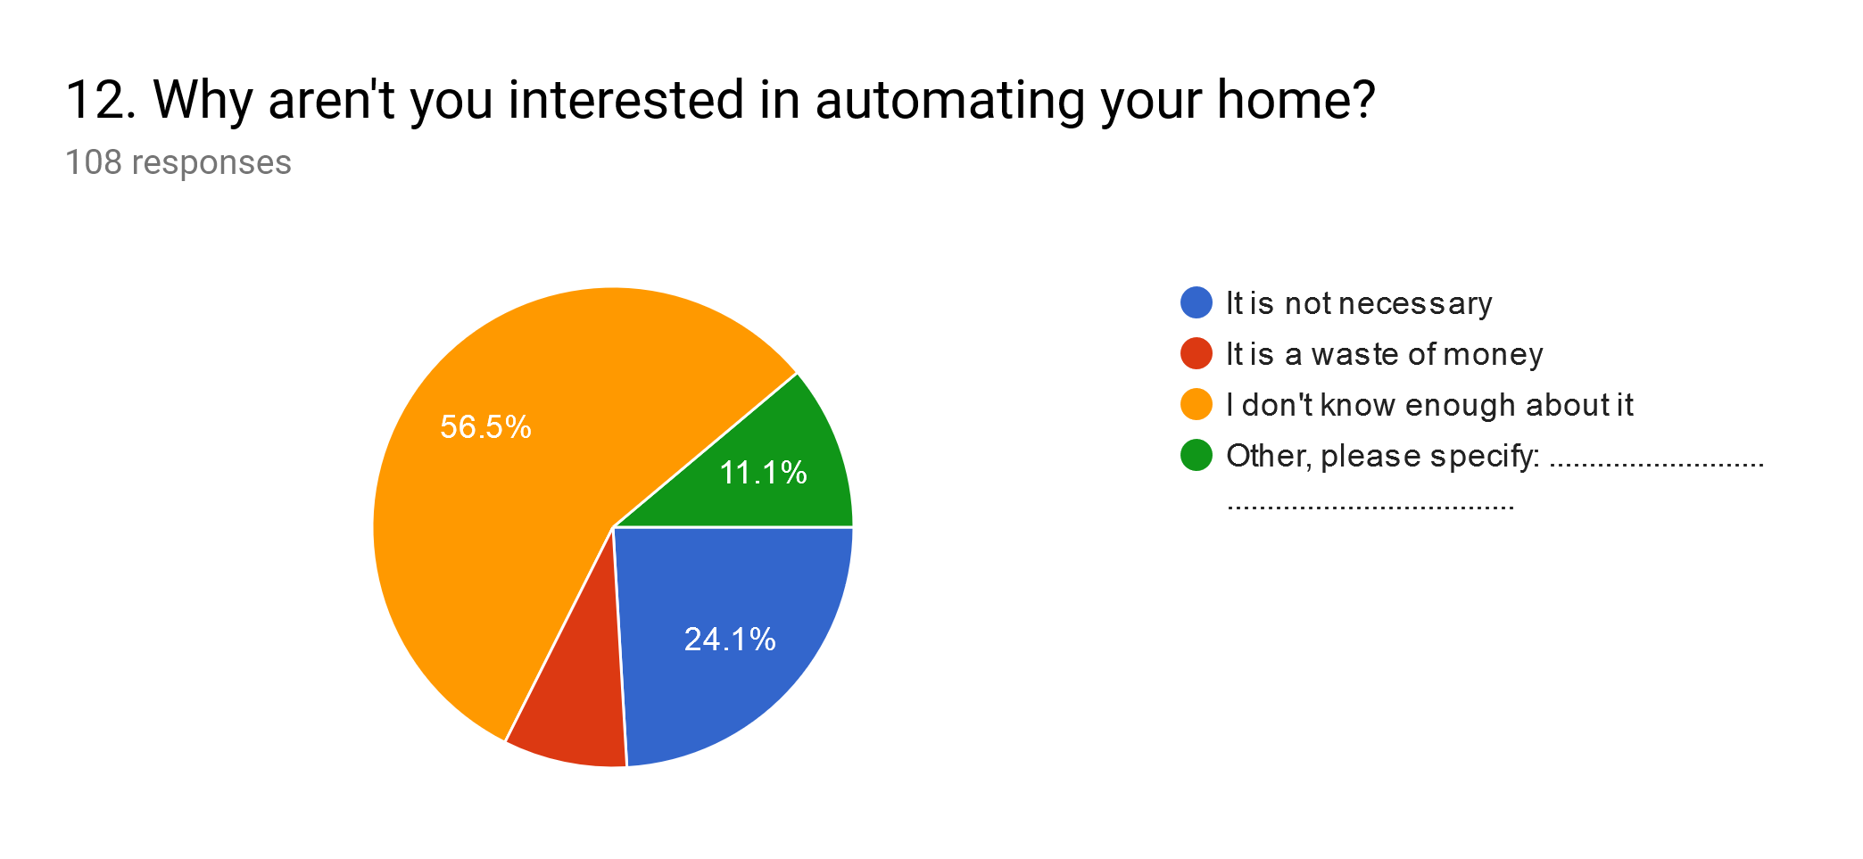

We had 108 responses for this question. Highest number of people didn’t know enough about automated homes. Some of them felt it was not necessary and few of them thought it is a waste of money and some had their own reasons.

## What are your major worries about smart homes, if any? (Including a list of possible worries)

* misuse of technology
* Hackers
* Hacking
* Nothing
* security and high cost of electricity
* power failure
* costing maintenance in case if it comes
* in case of power failures or internet it will be difficult to back to normal life and security backup
* what if gets hacked by hackers
* if it is affordable, I am willing to get more knowledge and provider to avail such product
* bugs
* money
* the gadgets and products are no available in Uganda, have all the knowledge about it but again most of the things are not available in the country
* not really
* People more depends upon technology, spam, hacking, etc.
* it makes people unhealthy
* it makes people lazy
* power failure, breakdown of IT or software collapse, sudden wear and tear of any equipment
* in future it will be must requirement like auto locks, security camera etc.
* Still at preliminary stage. in case of AMC, and rectifying system might be very difficult
* Technical issues
* System failure
* Not easy to maintain
* System failure and Hacking
* Privacy is interfered with. Once something is smart, the information is kept and someone might choose to 'hack' into my smart home
* In case of any slowness in the system it changes all the settings
* Hackable
* Causes laziness, which leads to health problems.
* Electricity bills Creates laziness
* Failures due to technological error
* Technical failures
* It can lead to security problems.
* Technological problems can create a worry
* None
* Security/unpredictability
* 1. More Technical Security Threats may increase... Like hackers are hacking smart phones itself I don't think it's a big deal to hack smart homes... They may get to know our personal lives.... 2.Thinking smart homes save their times is foolish like I don't think it may take a lot of time to check if we switched on or off .....3. Cost 4.Internet Reliance....... I personally don't really agree with smart homes.... Well there are many more reasons
* Very expensive and not fully automated yet
* Having safety
* Security
* No worries
* Power dependent
* Theft and hacks
* A times things might go wrong
* When is power cut
* None
* May take time to learn how to use it
* Maybe hacking
* If power or electricity breaks out, you find it difficult to access some of the house holdings
* No idea
* Can easily be hacked as it's full of technology
* Peoples becomes lazy
* Security
* they can be hacked / not an efficient means to control the house in a Country like Uganda
* Electronic
* Power outage, control in wrong hands, misjudgements, short-circuit, privacy risk.
* Internet connection. Problems of electricity Problems of wiring
* It can be hacked into as it relies on internet and also it’s too expensive for the things you could do every day without using that technology
* If Lights gone
* Expenses will be a lot makes one lazy
* Security can be misplaced or on
* How easy would they be to maintain and use.
* Hackers
* Sometimes technologies can lead to disasters
* Easily be hacked as it's made of technology
* Cyber security. Health
* May make one lazy
* Information theft and spying
* Its prone to Cyber-attacks.
* Increased household expenses
* Security breach, misjudged situation, and mistake by machine could cause many blunders.
* Misuse by wrongful people
* Power failure, unwanted power surges, failure of the whole system leading to lock down of house, can be hacked by hackers
* Breach of Privacy
* Price
* the security system is not safe if controlled by internet

We had 80 responses for this question. Major worries about the smart homes were security issues like hacking, privacy, power failure, expensive and makes people lazy.

## When do you think smart homes will become a part of our everyday life?

* Soon
* 2050
* after 10 years
* soon
* 2030
* Don’t know
* 5-10 years from now
* long
* nearest future
* After 10 years it will be more technological revolution and smart technology will implement
* Maybe in the future generations
* let me work more smart to have smart-home, it’s not for my need
* in the next century
* when it is easily available at cheap price
* It has already started but being in every single house will take 2-3 years
* by 2030
* In coming future it's going to happen. smart homes shall become part of our everyday life
* very soon
* when all the smart home technology becomes completely secured to use with all the backup in one place in case of any of the above worries about smart homes
* maybe
* in next few years maybe 5-10 years’ time
* next generation in developed countries only
* maybe in next 3-5 years
* That will take long
* Already
* 30yrs from now
* This depends on the awareness of smart homes and how people are adaptive to it. Plus the cost involved both install and maintenance. But it's gonna be some good years from now.
* They are there, but will probably be more common 10-20 years from now.
* Not sure but in the future
* In 10 years
* when many companies producing smart homes gadgets, competitive and reduce prices
* Partly the near future
* By 2030
* Yes in some years
* 10 years’ time
* I will try as soon as possible to get it.
* In some short time to come
* In the next 15 years
* no idea
* They already are
* I hope they don't
* Next generation
* It will become soon
* Near future
* May be in future
* When u not at Home you always home
* In 5 years
* Not sure may be 20 years
* Make human lazy...😉🤣
* Think in the future generation
* Wen tech is more reliable and hack proof
* In the next 20 years
* Possibly in the coming few years
* May be after 20 years
* When technological management is efficient and point
* Not sure
* 2028
* Most probably in the coming 6 or 7 years
* 5 years
* 5 years in developed countries 20 years in developing countries
* 15years
* When am rich
* 2025
* 10 years from now
* In coming 10years
* Depends on time
* By 2022
* 2024
* It depends
* They save time
* Today
* In next 5 yrs.
* When one has enough money to install gadgets and has knowledge how to use them.
* Soon in the coming few years
* 2100
* In the next 10yrs
* Hopefully in the next 10 years
* No
* Soon enough
* After some years
* In 5 years
* Am not really sure about that but I guess they will be around in future
* When we are not at home and also we manage it from another place
* In the distant future
* 22
* I don’t think they will

We had 94 responses for this question. Most of the answers were in the coming future like 5 to 10 years, some even said 2030 and few said very soon.

# CONCLUSION

After the discussion on results for all questions we concluded that most of the people had a little bit of knowledge about smart homes and they were interested in using the smart home system to automate their homes.

Since most of the people were interested in technological products we are also going to use a mobile application to override the activities of home alongside the Smart Home System.

Since most of the people agreed on automating of lights, doors, TV, fans, and alarms; the Smart Home System will mainly automate the control of these appliances to make their lives easy and comfortable.

# References

[1] N. Malik and Y. Bodwade, “Literature Review on Home Automation System,” *IJARCCE*, 2017.

# [2] B. THAKKAR, "SMART HOME QUESTIONNAIRE", *Google Docs*, 2019. [Online]. Available: https://docs.google.com/forms/d/e/1FAIpQLSfg4iAQ3Lkb03k6SAhm2Sw17HHlLKjac1dkoZmtfsQGj2B9DA/viewform?usp=pp_url. [Accessed: 17- Dec- 2019].

# APPENDIX

## Questionnaire [2]

**SMART HOME QUESTIONAIRE**

We are students from Makerere University pursuing a Bachelor’s Degree in Software Engineering, year four. We are carrying out a survey to establish the need for a smart home. The information acquired will be used to design a system to automate activities in a home in order to make life at home secure, easy and fun.

1. What is your Gender?

Mark only one oval.

MALE

FEMALE

1. What is your Age?

Mark only one oval.

15-25

26-35

36-50

Above 50

1. Have you heard about smart homes before?

Mark only one oval.

Yes

No

1. If yes, what have you heard about them? What do you know about smart homes?

…………………………………………………………………………………………………………………………………………………………………………………………………………………………………………………………………………….....

**HOME AUTOMATION DEFINITION...**

Home automation (also known as smart home) is automation of the home, Home automation may include centralized control of lighting, heating, ventilation, appliances, and other systems, to provide improved convenience, comfort, energy efficiency and security. Home automation for the elderly and disabled can provide increased quality of life for persons who might otherwise require caregivers or institutional care. (Wikipedia)

1. Do you trust this kind of products?

Mark only one oval.

Yes completely

Yes somehow

Not really

1. Are you generally interested in technological products?

Mark only one oval.

Yes

It depends

No

1. Would you be interested in automating your home?

Mark only one oval.

Yes

No

Maybe

1. Why would you like to automate your home?

Tick all that apply.

For its convenience, to save time

For security reason

I like technological gadgets

To save money (energy saving)

Other, please specify: ...................................................................................

1. Which of these functions would be the most important for you? Please rank the options from most important (1) to least important (5).

Mark only one oval per row.

5

1

2

3

4

Open the door without key

Automatic control of the lights

Automatic shutters and blinds

The possibility to manage your

home from Internet

Manage the heating

Communication system (between

multiple rooms)

Automatic management of the

home alarm system

Automatic closing and opening of

curtains

Managing Home appliances

automatically (TV, refrigerator, AC,

Washing machine, microwave,

Oven)

CCTV cameras (security system)

1. If you were to install this kind of products at home, how would you prefer to do?

Mark only one oval.

Choose, receive it at home and install it yourself

Get an expertise before choosing and install it yourself

Get an expertise before choosing and having it installed by a professional

Have an all included solution

1. Would you allow your smart home to record your house health status? (In case of power failure, smoke, fire) Mark only one oval.

Yes

No

1. Why aren't you interested in automating your home?

Mark only one oval.

It is not necessary

It is a waste of money

I don't know enough about it

Other, please specify: ...............................................................

1. What are your major worries about smart homes, if any? (Including a list of possible worries)

………………………………………………………………………………………………………………………………………………………………………………………………………………………………….....

1. When do you think smart homes will become a part of our everyday life?

……………………………………………………………………………………………………………………………………………………………………………….........

|  |  |
| --- | --- |
|  |  |